Pimoroni Unicorn Hat - 8x8 RGB LED Shield for Raspberry Pi A+/B+

Adafruit PRODUCT ID: 2288

<https://www.adafruit.com/product/2288>

<https://shop.pimoroni.com/products/unicorn-hat>

Spacing of the LED array 6.4mm???

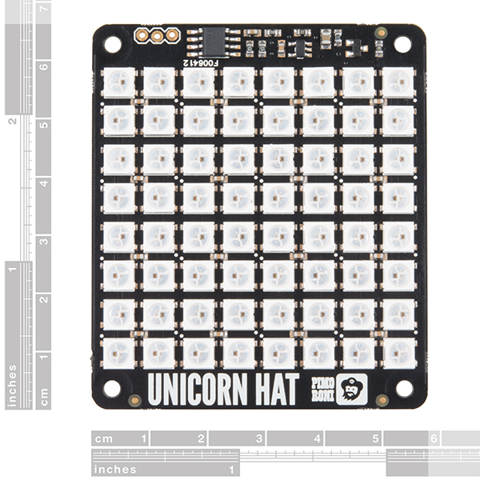

TECHNICAL DETAILS

* 65mm x 56mm x 6.5mm / 2.6" x 2.2" x 0.26"
* Weight: 20g

# DESCRIPTION

Snap the [Pimoroni](http://shop.pimoroni.com/)**Unicorn Hat** on top of a Raspberry Pi [model A+](https://www.adafruit.com/products/2266) or a [model B+](https://www.adafruit.com/products/1914) for a fun 8x8 RGB LED matrix powered directly from the Pi.

Unicorn HAT provides a wash of controllable color that is ideal for mood-lighting, 8x8 pixel art, persistence of vision effects, status indications, or just blasting colour into your surroundings.

* 64 RGB LEDs (WS2812B) each wtih 24-bit RGB color
* Python API (NeoPixel compatible!)
* EEPROM with Raspberry Pi HAT configuration details
* LED data driven via DMA over PWM Pin #18

# Unicorn HAT

What's going to protect your beloved Raspberry Pi from an onslaught of rainbow-coloured fusion? That's right, it's Unicorn HAT.

Sporting a matrix of 64 (8 x 8) RGB LEDs and powered directly from the Pi, this is the most compact pocket aurora available.

Unicorn HAT provides a wash of controllable colour that is ideal for mood-lighting, 8x8 pixel art, persistence of vision effects, status indications, or just blasting colour into your surroundings.

[The MagPi](https://www.raspberrypi.org/magpi-issues/MagPi42.pdf) said that Unicorn HAT was "one of the coolest HATs around"

## **Features**

* 64 RGB LEDs (WS2812B)
* LED data driven via DMA over PWM
* [Unicorn HAT pinout](https://pinout.xyz/pinout/unicorn_hat)
* Compatible with all 40-pin header Raspberry Pi models
* [Python library](https://github.com/pimoroni/unicorn-hat)
* Comes fully assembled

## **Software**

We've put together a [Unicorn HAT Python library](https://github.com/pimoroni/unicorn-hat) to make it a breeze to use, including lots of beautiful examples of what it can do.

## **Notes**

* **Warning**: WS2812 LEDs are bright enough to cause eye pain, do not look at them directly when brightly lit. We recommend the use of a [diffuser](https://shop.pimoroni.com/products/pibow-modification-layers).
* **Photo-sensitivity warning**: flashing, strobing, and patterns of lights may cause epileptic seizures. Always take care and immediately stop using if you feel unwell (dizziness, nausea, affected vision, eye twitching, disorientation).
* **Power**: Unicorn HAT requires a >2A microUSB power supply for your Pi. We recommend [the official Raspberry Pi power supply](http://shop.pimoroni.com/products/raspberry-pi-universal-power-supply).
* **Compatibility (audio)**: as Unicorn HAT uses PWM and GPIO18, it will interfere with analogue audio playback (random colour patterns and flickering). HDMI should work just fine! :D